该模板为本刊正式出版文章的部分内容以作格式解释，投稿时请参考并设置稿件格式（包括单位、标点符号的使用）。修改稿文章需设置“行号”和“1.5倍行距”，正式录用稿不必。
燕辽地区土城子组古生物组合与陆相
侏罗系-白垩系界线年代地层*
万晓樵^{1**} 孙立新² 李 玮³
1 生物地质与环境地质国家重点实验室, 中国地质大学, 北京100083;
2 中国地质调查局天津地质调查中心, 天津 300170;
3 青海大学地质工程系, 西宁810016
提要 土城子组是一套广泛发育于燕辽地区的陆相红色碎屑沉积岩系。

关键词 土城子组 化石组合 侏罗系-白垩系界线 年代地层 燕辽

Terrestrial fossil assemblages of Tuchengzi Formation and Jurassic-Cretaceous boundary chronostratigraphy in Yanliao area
WAN Xiao-qiao¹, SUN Li-xin² and LI Wei³
1 State Key Laboratory of Biogeology and Environmental Geology, China University of Geosciences, Beijing 100083, China;
2 Tianjin Center of Geological Survey, China Geological Survey, Tianjin 300170, China;
3 Department of Geological Engineering, Qinghai University, Xining 810016, China
Abstract The Jurassic and Cretaceous strata in northern China are mostly of terrestrial origin.

SYSTEMATIC PALEONTOLOGY

Superfamily Pupilloidea Turton, 1831
Family Vertiginidae Fitzinger, 1833
Truncatellina Lowe, 1852
Type species Pupa linearis R.T. Lowe, 1852
Diagnosis Shell very small, nearly cylindrical-shape; embryonic shell blunt and dome-shaped.
Truncatellina dilatatus sp. nov.
urn:lsid:zoobank.org:act:3ED80760-5C38-4111-865E-C59CEE19B1CF
(Figs. 1-E, 1-F)
Etymology The species name is derived from the Greek dilatatus, meaning inflated.
Material Holotype, NIGP171282.
Diagnosis Shell very small.
Remarks Truncatellina dilatatus sp. nov. is established based on the shell characters.
Locality and horizon Upper Albian–Lower Cenomanian; northern Myanmar.

Key words Tuchengzi Formation, fossil assemblage, J/K boundary, chronostratigraphy, Yanliao

1 前 言
近年来, 传统的生物地层学研究积淀正被日渐兴起的年代地层学数据结果引发诸多挑战, 侏罗系、白垩系界线的划分即是其中倍受关注的一例。
2 土城子组的发育
3 土城子组的化石组合
土城子组以陆相红色碎屑沉积为主。

3. 1 叶肢介
土城子组的叶肢介化石。
1) Pseudograpta-Beipiaoestheria-Mesolimnadia组合。
2) Pseudograpta-Monilestheria-Sinograpta组合。
3) Yanshanoleptestheria-Pingquania-Ling-yuanella组合。

3. 2 介形类
土城子组的介形类主要产于辽西、辽北、辽东及冀北地区的土城子组中、下部, 仅在冀北平泉县杨树岭盆地产于上部, 共发现10属70余种, 可划分为如下两个组合(庞其清, 1982; 杨仁泉, 1985; 王五力等, 2004; 王思恩等, 2013) (图2):
1) Cetacella substriata-Mantelliana alta-Darwi-nula bapanxiaensis 组合。
2) Djungarica yangshulingensis-Mantelliana reniformis-Stenestroemia yangshulingensis组合。
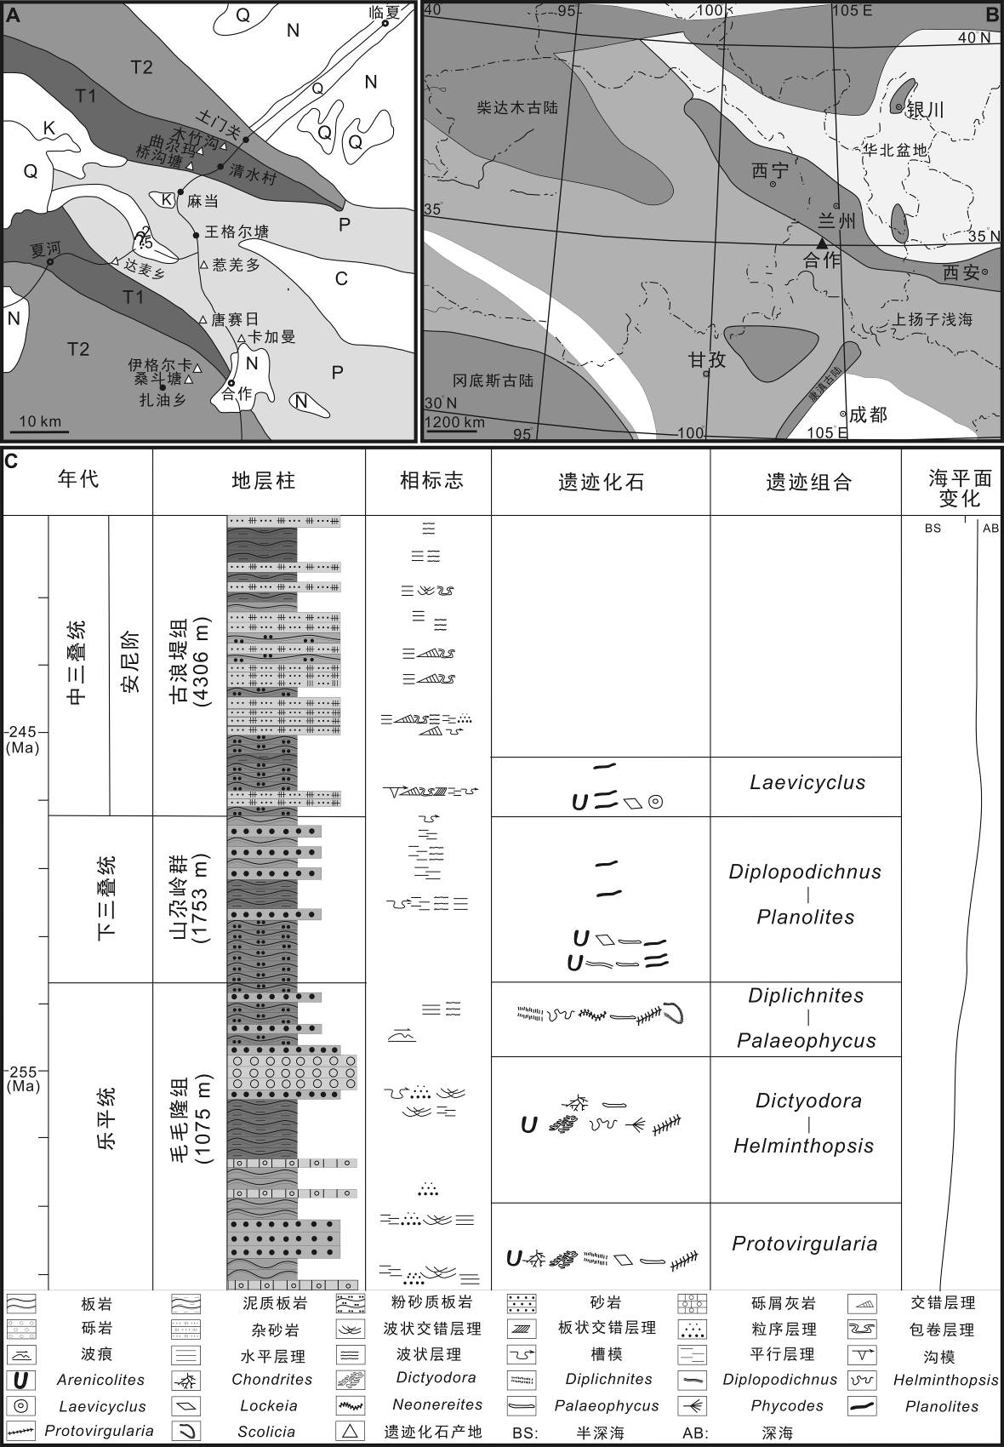
图1 研究区交通位置、古地理简图以及岩性柱状图(交通位置、古地理图据殷鸿福等, 1992; 王鸿祯, 1985修改)
Fig. 1 Location, paleogeographic map and stratigraphic column of study area (modified from Yin et al., 1992; Wang, 1985
4 系统古生物学
环口螺超科 Superfamily Cyclophoroidea Gray, 1847
倍唇螺科 Family Diplommatinidae Pfeiffer, 1856
奇美螺属 Genus Euthema Yu, Wang and Pan, 2018
模式种 Euthema naggsi Yu, Wang and Pan, 2018
产地层位 缅甸北部; 上Albian阶–下Cenomanian阶。
纳氏奇美螺 Euthema naggsi Yu, Wang and Pan, 2018
(图1-A–1-D)
2018 Euthema naggsi Yu, Wang and Pan, p. 255, fig. 1. A-B.
材料 NIGP171280 (图1-A, 1-B); NIGP 171281 (图1-C, 1-D)。
度量 NIGP171280: H = 2.2 mm; D = 1.04 mm; h = 0.65 mm; d = 0.56 mm。NIGP171281: H = 1.67 mm; D = 0.98 mm; h = 0.57 mm; d = 0.49 mm。
补充描述 壳体微小, 近圆柱形壳型, 右旋。
讨论 标本NIGP171280与NIGP171281存在细微区别。
产地层位 缅甸北部; 上Albian阶–下Cenomanian阶。
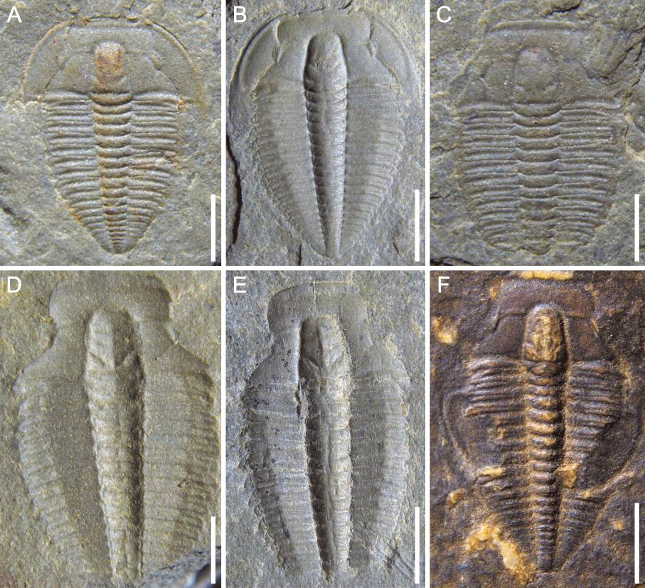
图2 Nangaops danzhaiensis标本的照片
Fig. 2 Photograph of Nangaops danzhaiensis
A, B为完整标本; C, D, E为缺少活动颊标本; F为活动颊翻转的标本。 标本编号依次为: Q51-1473、Q52-2740、Q51-645、Q52-230、QM-89、QM-204, Q与QM为分层号, 比例尺为2 mm。
A, B. the complete specimen; C, D, E. the lack of free cheeks; F. the free cheeks coved by thorax. Fossil number: Q51-1473, Q52-2740, Q51-645, Q52-230, QM-89, QM-204. Q and QM stand for stratification number, Scale bars = 2 mm.

表1 扫描电镜和体视显微镜获取的牙形刺图像数量统计表
Table 1 Dataset of conodont images under SEM and stereomicroscope
编号 | 中文名称 | 拉丁文名称 | 体视显微镜照片 |  | 扫描电镜照片 |  | 小计
编号 | 中文名称 | 拉丁文名称 | 训练集 | 测试集 | 训练集 | 测试集 | 小计
A | 中村圆柱刺 | Teridontus nakamurai | 78 | 5 | 89 | 10 | 182
B | 先祖肿刺 | Cordylodus proavus | 0 | 0 | 178 | 24 | 202
C | 叉开锯颚刺 | Serratognathus diversus | 272 | 31 | 64 | 12 | 379
D | 变异胡安颚刺 | Juanognathus variabilis | 216 | 21 | 24 | 8 | 269
E | 扁平小剑刺 | Scabbardella altipes | 177 | 13 | 38 | 13 | 241
F | 短尾哈玛拉刺 | Hamarodus brevirameus | 180 | 15 | 62 | 14 | 271
G | 角肿刺 | Cordylodus angulatus | * | * | 183 | 19 | 202
H | 马尼托罗斯刺 | Rossodus manitouensis | 168 | 12 | 32 | 8 | 220
总计 |  |  | 1091 | 97 | 670 | 108 | 1966
注: *代表计数0。
Note: * represents 0.
6 结 论

致谢 评审专家提出宝贵修改建议, 特此致谢。
参考文献 (References) (中文文献需列两次, 先中文, 后译英文并后注(in Chinese); 若原文有英文部分需特别后注(in Chinese with English abstract/ in Chinese with English summary), 文献以字母顺序排列。所有参考文献需添加DOI号。
河北省地质矿产局, 1989. 河北省、北京市、天津市区域地质志. 中华人民共和国地质矿产部地质专报, 区域地质, 第15号. 北京: 地质出版社. 1–741.
和政军, 牛宝贵, 张新元, 2007. 辽西朝阳地区晚侏罗世逆冲断裂及同构造沉积盆地系统. 地质论评, 53: 152–163.
林妙琴, 李建国, 彭俊刚, 2016. 辽西北票四合屯早白垩世土城子组三段孢粉组合及其意义. 微体古生物学报, 33: 261–271.
庞其清, 1982. 河北燕山地区中、上侏罗统介形类化石及其意义. 河北地质学院学报, 1–2: 89–94.
张望平, 1989. 中国东部一些地区侏罗纪孢粉组合. 见: 中国地质科学院地质研究所地层组编, 中国东部构造–岩浆演化及成矿规律(二), 中国东部侏罗纪—白垩纪古生物及地层. 北京: 地质出版社. 1–20.
朱国信, 1980. 双壳及腹足类部分. 见: 中国地质科学院沈阳地质矿产研究所编, 东北地区古生物图册(二). 北京: 地质出版社. 8–58.
Davis G A, 2005. The Late Jurassic “Tuchengzi/Houcheng” Formation of the Yanshan fold-thrust belt: an analysis. Earth Science Frontier, 12: 332–345.
Haq B U, Hardenbol J, Vail P R, 1987. Chronology of fluctuating sea levels since the Triassic. Science, 235: 1156–1167.
Hardland W B, Cox A V, Llewellyn P G, Pickton C A G, Smith A G, Walters R, 1982. A Geologic Time Scale. Cambridge: Cambridge University Press. 1–131.
Hebei Bureau of Geology and Mineral Resources, 1989. Regional Geology of Hebei Province, Beijing and Tianjin. Special Report on Geology of the Ministry of Geology and Mineral Resources of the People’s Republic of China, Regional Geology, No. 15. Beijing: Geological Publishing House. 1–741 (in Chinese).
He Zheng-jun, Niu Bao-gui, Zhang Xin-yuan, 2007. Late Jurassic thrusting and syntectonic sedimentary basin systems in the Chaoyang region, weatern Liaoning. Geological Review, 53: 152–163 (in Chinese with English abstract).
Kulp J L, 1961. Geologic time scale. Science, 133: 1105–1114.
Lin Miao-qin, Li Jian-guo, Peng Jun-gang, 2016. Early Cretaceous palynological assemblages from the third member of the Tuchengzi Formation at Sihetun, Beipiao County, western Liaoning Province, northeast China and their implications. Acta Micropalaeontologica Sinica, 33: 261–271 (in Chinese).
Odin G S, 1982. Numerical Dating in Stratigraphy, Parts 1 and 2. Chichester: John Wiley and Sons. 1–630, 633–1040.
Ogg J G, Ogg G, Gradstein F M, 2016. The Concise Geologic Time Scale 2016. Amsterdam: Elsevier. 1–229.
Sun Li-xin, Zhao Feng-qing, Wang Hui-chu, Gu Yong-chang, Ji Shi-ping, 2007. Correlationship of Tuchengzi Formation and implications of the basin tectonic evolution in the intracontinental Yanshan Orogenic Belt. Acta Geologica Sinica, 81: 445–453.
Tian Shu-gang, Li Pei-xian, Liu Yong-qing, Pang Qi-qing, Niu Shao-wu, 2004. Standard strato-sequence of terrestrial Jurassic-Cretaceous boundary strata in Luanping, northern Hebei. Professional Papers of Stratigraphy and Paleontology, 28: 247–266.
Wang Wu-li, Zhang Hong, Zhang Li-jun, Zheng Shao-lin, Yang Fang-lin, Li Zhi-tong, Zheng Yue-juan, Ding Qiu-hong, 2004. Standard Sections of Tuchengzi Stage and Yixian Stage and Their Stratigraphy, Palaeontology and Tectonic-volcanic Actions. Beijing: Geological Publishing House. 1–244.
Xing Li-da, Liu Yong-qing, Kuang Hong-wei, Klein H, Zhang Jian-ping, Burns M E, Chen Jun, Wang Ming-wei, Hua Jian, 2014. Theropod and possible ornithopod track assemblages from the Jurassic–Cretaceous boundary Houcheng Formation, Shang-yi, northern Hebei, China. Palaeoworld, 23: 200–208.
Xing Li-da, Zhang Jian-ping, Lockley M G, McCrea R T, Klein H, Alcalá L, Buckley L G, Burns M E, Kümmell S B, He Qing. 2015. Hints of the early Jehol Biota: important dinosaur footprint assemblages from the Jurassic-Cretaceous boundary Tuchengzi Formation in Beijing, China. PLoS ONE, 10: e0122715.
Zhang Wang-ping, 1989. Jurassic sporo-pollen assemblages from some parts of eastern China. In: Stratigraphical Group of Institute of Geology, Chinese Academy of Geological Sciences (ed.), Tectonic-magmatic Evolution and Metallogeny of Eastern China (2), the Palaeontology and Stratigraphy of the Jurassic and Cretaceous in Eastern China. Beijing: Geological Publishing House. 1–20 (in Chinese).
Zhao Xi-jin, Cheng Zheng-wu, Xu Xing, 1999. The earliest ceratopsian from the Tuchengzi Formation of Liaoning, China. Journal of Vertebrate Paleontology, 19: 681–689.

